Step 1: Open RPA and use the following format to search for the Patients Eligibility.

**For IL** :

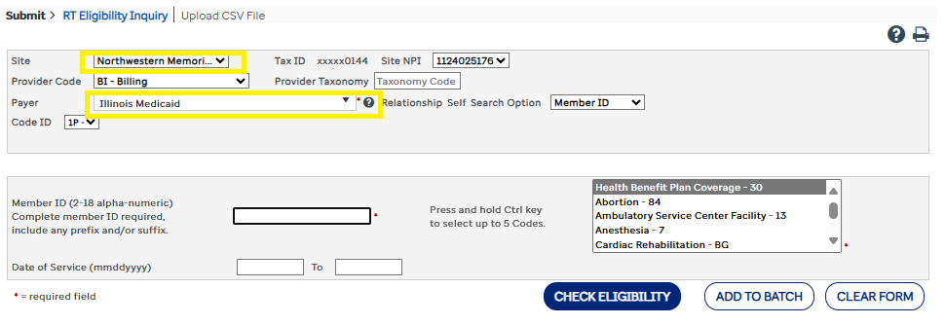

**For MO**:

**For WA**:

Step 2: We can use different option to check eligibility on RPA depends on the available data on excel file(live tracker).

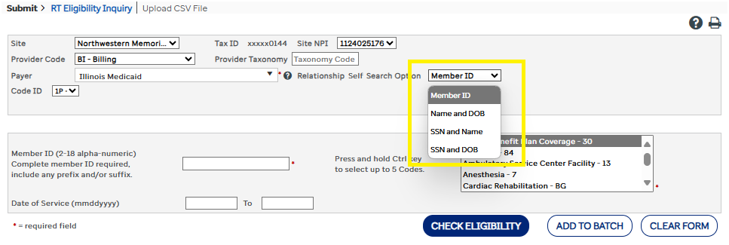

Step 3: Proceed to Step 4 if the eligibility is Active. If eligibility doesn’t show active (REJECTED , INACTIVE , etc.) then note the Live tracker regarding the status of eligibility.

Example:

Status : No Eligibility

OGA Notes: Rejected

Step 4: If the eligibility is Active, then Go to PACE click visit then change the ***status of visit*** from hold to Manager Review. Then the ***Was pt screened*** put Yes , ***Screen date*** change to today or yesterday's date and then hit save.

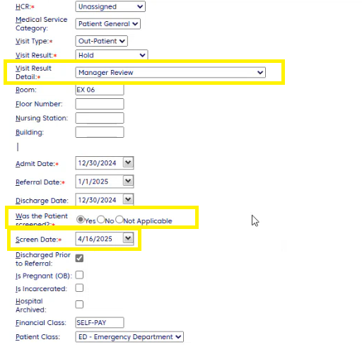

Step 5: Add note on PACE with the following format:

HCR , Custom Note and Private.

Format: RPA shows active Medicaid RIN # (place RIN number)

Example:

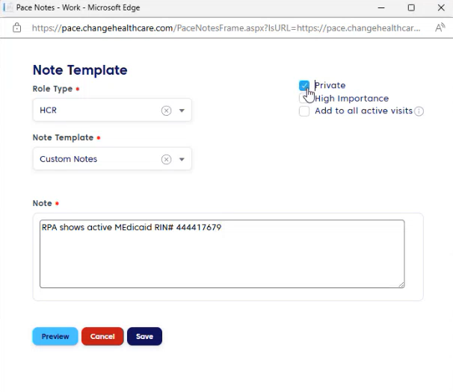

Step 6: Go back to RPA. Print the page(right click select print). Save the PDF as (Name of the Patient POS)

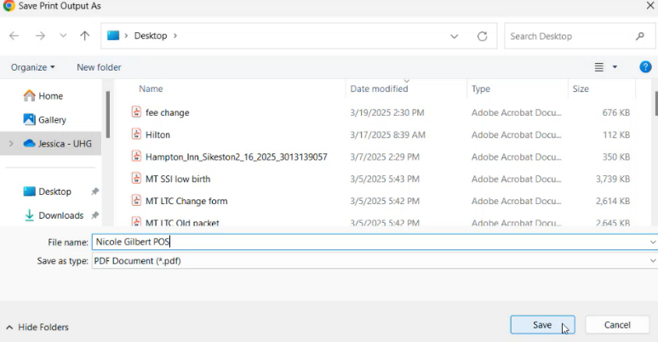Example: Nicole Gilbert POS

Step 7: Once PDF is downloaded, go back to PACE and click **Evidence**. Please follow this format in uploading the evidence:

Hit save and proceed to the next patient.

Reminders:

If the account is on billing list, just add evidence (Pdf from RPA)

Active but temporary coverage for IL - Treat as not active